**PRACTICAL - 5**

**AIM: To Perform various data manipulation commands, aggregate functions and sorting concept on all created tables.**

**QUERIES:**

**(1) List total deposit from deposit.**

SELECT SUM(AMOUNT) FROM DEPOSIT2;

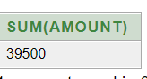

**(2) List total loan from karolbagh branch**   
  
SELECT SUM(AMOUNT) FROM BORROW WHERE BNAME = 'KAROLBAGH';

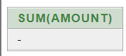

**(3) Give maximum loan from branch vrce.**SELECT MAX(AMOUNT) FROM BORROW WHERE BNAME= 'VRCE';

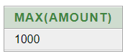

**(4) Count total number of customers**

SELECT COUNT(CNAME) FROM CUSTOMERS;

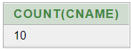

**(5) Count total number of customer’s cities.**SELECT COUNT(CITY) FROM CUSTOMERS;



**(6) Create table supplier from employee with all the columns.**CREATE TABLE SUPPLIER AS SELECT * FROM EMPLOYEE;

SELECT * FROM EMPLOYEE;



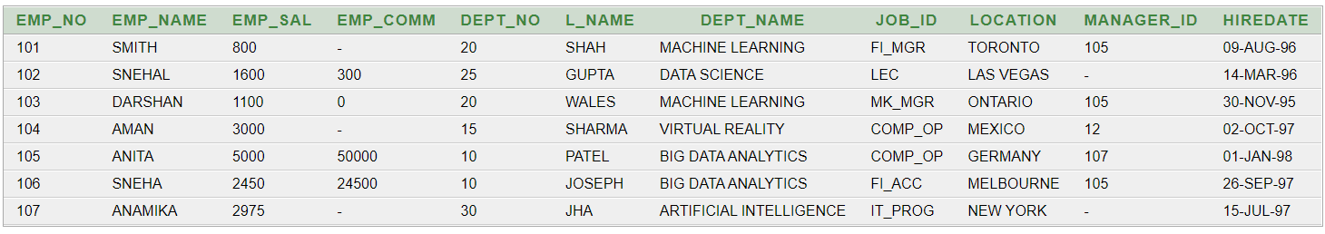

**(7) Create table sup1 from employee with first two columns.**  
CREATE TABLE SUP1 AS SELECT EMP_NO, EMP_NAME FROM EMPLOYEE;



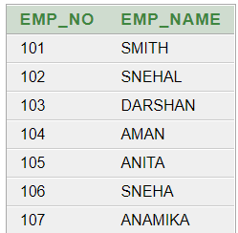

**(8) Create table sup2 from employee with no data**CREATE TABLE SUP2 AS SELECT * FROM EMPLOYEE WHERE EMP_NO = NULL;

SELECT * FROM EMPLOYEE;



**(9) Insert the data into sup2 from employee whose second character should be ‘n’ and string should be 5 characters long in employee name field.**

INSERT INTO SUP2 SELECT * FROM EMPLOYEE WHERE EMP_NAME LIKE '_N___';

SELECT * FROM SUP2;



**(10) Delete all the rows from sup1.**

DELETE SUP1;



**(11) Delete the detail of supplier whose sup_no is 103.**

DELETE FROM SUPPLIER WHERE EMP_NO=103;

SELECT * FROM SUPPLIER;

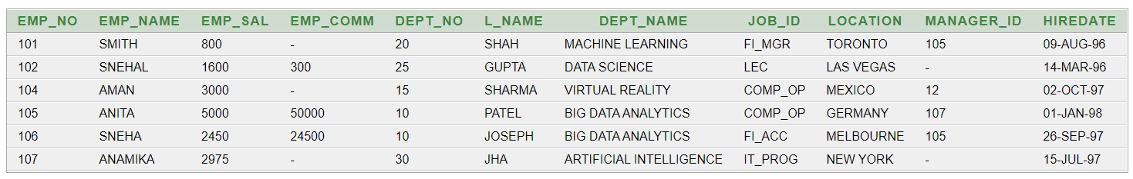

**(12) Rename the table sup2.**

ALTER TABLE SUP2 RENAME TO GLOBAL;

SELECT * FROM GLOBAL;



**(13) Destroy table sup1 with all the data.**

DROP TABLE SUP1



**(14) Update the value dept_no to 10 where second character of emp. name is ‘m’.**

UPDATE EMPLOYEE SET DEPT_NO=10 WHERE EMP_NAME LIKE '_m%';

SELECT * FROM EMPLOYEE;

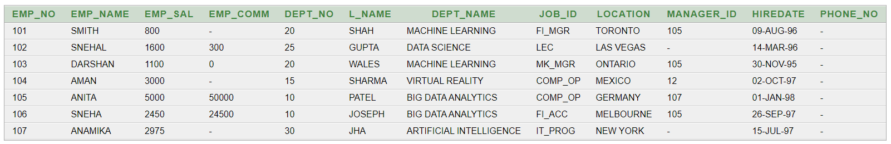

**(15) Update the value of employee name whose employee number is 103.**

UPDATE EMPLOYEE SET EMP_NAME='YATHARTH' WHERE EMP_NO=103;

SELECT * FROM EMPLOYEE;

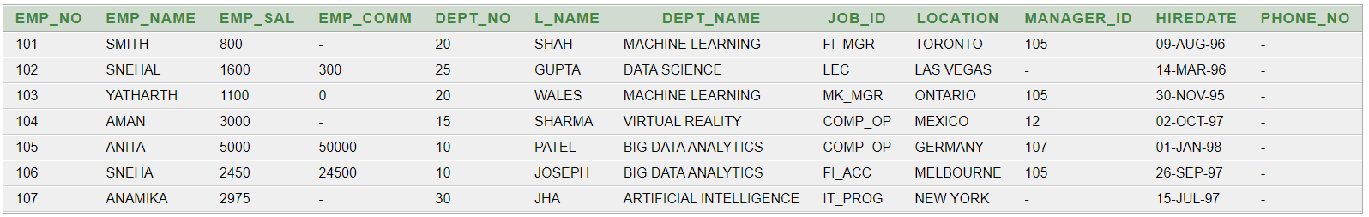

**(16) Add one column phone to employee with size of column is 10.**

ALTER TABLE EMPLOYEE ADD PHONE_NO NUMBER(10,0);

SELECT * FROM EMPLOYEE;



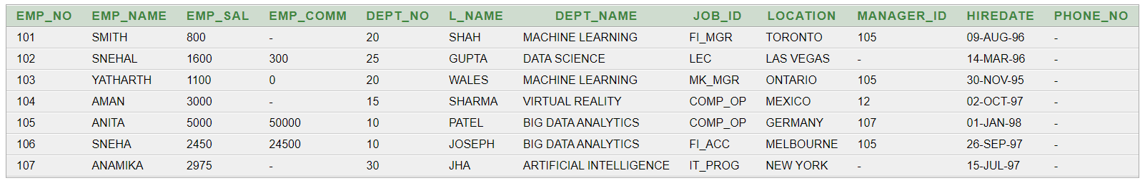

**(17) Modify the column emp_name to hold maximum of 30 characters.**

ALTER TABLE EMPLOYEE MODIFY EMP_NAME varchar(30);

SELECT * FROM EMPLOYEE;



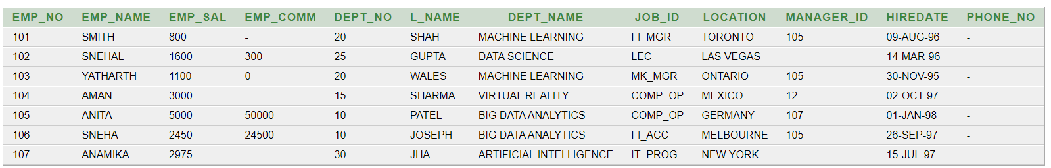

**(18) Count the total no as well as distinct rows in dept_no column with a condition of salary greater than 1000 of employee**

SELECT COUNT(DISTINCT DEPT_NO) FROM EMPLOYEE WHERE EMP_SAL > 1000;

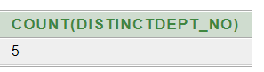

**(19) Display the detail of all employees in ascending order, descending order of their name and no.**

SELECT * FROM EMPLOYEE ORDER BY EMP_NAME ASC , EMP_NO DESC;

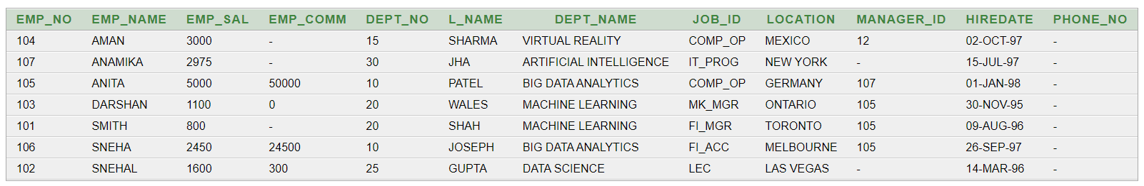

**(20) Display the dept_no in ascending order and accordingly display emp_comm in descending order.**

SELECT * FROM EMPLOYEE ORDER BY DEPT_NO ASC, EMP_COMM DESC;

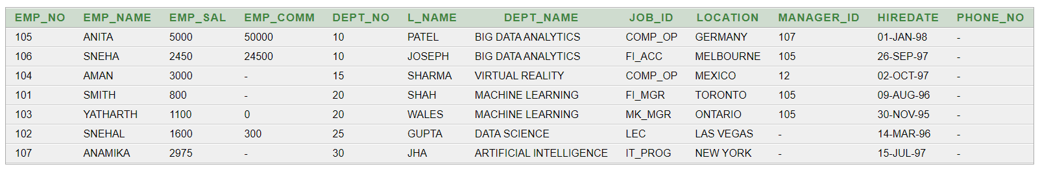

**(21) Update the value of emp_comm to 500 where dept_no is 20.**

UPDATE EMPLOYEE SET EMP_COMM = 500 WHERE DEPT_NO = 20;

SELECT * FROM EMPLOYEE;

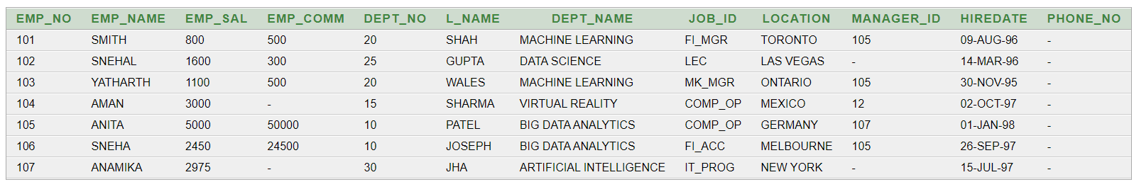

**(22) Display the emp_comm in ascending order with null value first and accordingly sort employee salary in descending order.**

SELECT EMP_COMM, EMP_SAL FROM EMPLOYEE ORDER BY EMP_COMM ASC NULLS FIRST, EMP_SAL DESC;

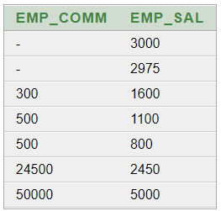

**(23) Display the emp_comm in ascending order with null value last and accordingly sort emp_no in descending order.**

SELECT EMP_COMM, EMP_NO FROM EMPLOYEE ORDER BY EMP_COMM ASC NULLS LAST, EMP_NO DESC;

